Lancashire County Council's Traveller sites
Consultation report – 2019

Melissa Sherliker, Mike Walker, Mick Edwardson
and Stephanie Windross

August 2019

For further information on the work of Business Intelligence please contact us at
Business Intelligence
Lancashire County Council
County Hall
Preston
PR1 8XJ
Tel: 0808 1443536
www.lancashire.gov.uk/lancashire-insight

Contents

1. Executive summary 3

1.1 Key findings – residents and general public 3

1.2 Main findings – partner organisations 4

1.3 Other responses to the consultation 4

2. Introduction 5

3. Methodology 6

3.1 Limitations 7

4. Main findings – residents and general public 8

4.1 Which site are you responding about? 8

4.2 Views on our proposal for the Traveller sites 8

5. Main findings – partner organisations 12

5.1 Which site are you responding about? 12

5.2 Views on our proposal for the Traveller sites 13

6. Other responses to the consultation 14

6.1 Lancaster City Council 15

6.1 Xaverian Mission Spirituality Centre 15

6.2 Morecambe Bay Clinical Commissioning Group 16

6.2 Leighton Street Caravan Park 17

Appendix 1 - Demographic breakdown – all respondents 19

Appendix 2 - Demographic breakdown – residents at the Traveller sites 21

Executive summary

This report summarises the response to Lancashire County Council's consultation on Lancashire County Council's Traveller sites.

For this consultation, we asked residents, the public and our partners to give their views. Before the consultation began, letters were sent to all residents telling them of the consultation process. The three sites were visited by county council staff to tell residents about the formal consultation dates and when council staff would be on site. Council staff delivered the questionnaires to the caravans on the sites, explained the ways of taking part in the consultation, how to get additional questionnaires if needed, and helped to explain and fill in the questionnaire if required. Contact details for Advocacy Access were also given.

An electronic version of the consultation questionnaire was available online at www.lancashire.gov.uk.

The fieldwork ran for eight weeks, between 7 May to 3 July 2019. In total, 191 completed questionnaires were returned (35 paper questionnaire responses and 156 online questionnaire responses).

Key findings – residents and general public
    - Which site are you responding about?
- Almost two-thirds (63%) of respondents said they were responding about Mellishaw Park in Morecambe, and about two-in-five said they were responding about Leighton Street in Preston (42%) and Altham near Accrington (39%). 23% of respondents indicated that they were responding about all three sites.

    - Views on our proposal for the Traveller sites
- Around four-fifth (79%) of respondents disagreed with the proposal. For those respondents indicating they were a resident on one of the three sites, almost nine-in-ten (86%) disagreed.
- When asked their views on the proposal, respondents were more likely to comment that the county council should retain ownership of the sites and keep things as they are (71%), that people will lose their homes and be split up (23%) and that they felt there was no guarantee about what a private landlord could do, for example raising rents, evicting families or redeveloping the site for another use (18%). For those respondents indicating they were a resident on one of the three sites, they were more likely to comment that the county council should retain ownership of the sites and keep things as they are (87%) and that people will lose their homes and be split up (61%).
- If the proposal happened, respondents were most likely to say it would affect them directly in that they could be homeless and would be forced to live on the road (25%), not directly affected but that they believed the county council had a duty to provide safe sites (25%), and not directly but it would have an impact of Traveller families and the local community (22%). For those respondents indicating they were a resident on one of the three sites, almost all (97%) said it would affect them directly in that they could be homeless and would be forced to live on the road.
- If the sites were sold, respondents were most likely to comment there would need to be guarantees that new site owners maintain sites and not increase rents, evict families, redevelop the site as something else (29%), the impact on traveller families (including children) for the provisions for welfare, education, keeping family groups together would need to be considered (27%) and consideration of where current residents will be moved to and implications on their safety and impact on other communities (23%). For those respondents indicating they were a resident on one of the three sites, they were most likely to comment on the impact on traveller families (including children) for the provisions for welfare, education, keeping family groups together would need to be considered (61%).
- When asked about a potential buyer for a site, about three-quarters (78%) of respondents said a potential buyer should have an understanding of the Gypsy, Roma, Traveller (GRT) community and two-thirds (66%) said a potential buyer should have experience of running a Traveller site. For those respondents indicating they were a resident on one of the three sites, four-fifths (82%) said a potential buyer should have an understanding of the (GRT) community and three-quarters (74%) said a potential buyer should have experience of running a Traveller site.
- Considering what the council could do differently, respondents were most likely to mention that there should be alternative or better management of site and working with residents to reduce costs, improve services and be more efficient (68%). For those respondents indicating they were a resident on one of the three sites, four-fifths (82%) mentioned that there should be alternative or better management of site and working with residents to reduce costs, improve services and be more efficient.

Main findings – partner organisations
- Five respondents said they were responding about Mellishaw Park in Morecambe, with four responding about Altham near Accrington and three about Leighton Street in Preston.
- All six respondents disagreed with the proposal.
- When asked their views on the proposal, three respondents had concern for the loss of the sites and those who live on them, and three respondents said they were not cost effective.
- Two respondents mentioned that they thought people would be displaced and two respondents mentioned concern for the Traveller community's welfare.
- Three respondents said that selling the sites is not cost effective as it will have a knock-on effect to the local community.
- Four respondents said a potential buyer should have experience of running a Traveller site and four said a potential buyer should have an understanding of the Gypsy, Roma, Traveller community.
- When asked what the council could do differently, four respondents commented that Lancashire County Council should retain the sites.

Other responses to the consultation
- We received four emails/letters from organisations during the consultation period.
- One was from Lancaster City Council. The city council is keen to explore possible solutions with the county council for Mellishaw Park. They wish to continue to dialogue with the county council, with a view to the city council taking ownership of the site and either managing it directly or in a partnership with a social housing provider.
- One was from Xaverian Mission Spirituality Centre. The centre is appealing on behalf of the Travelling community and the Catholic Church to the county council to guarantee stability, inclusion and a dignified future to this section of our society. The potential impact that any decision could have on the Leighton Street site is detailed.
- One was from Morecambe Bay Clinical Commissioning Group. There are three areas of concern highlighted. Firstly, that there is evidence from other areas of the country that where the sale of other such sites has occurred, the new landlords increase the price of the rent or change the conditions of the rent agreement (eg no animals allowed), which then forces the travellers off the site. Secondly, this would leave many of the current residents homeless and therefore forced back onto the road; and in turn have a negative impact on health and wellbeing for all and diminished educational outcomes for the children, with increased risks around safeguarding. Thirdly, through the Poverty Truth Commission good relationships with this community have been established, and if these families move on from Mellishaw Park those relationships will be lost.
- One was received from Leighton Street Caravan Park. There is concern expressed about the impact that a change in site management could have on residents. There is particular concern mentioned for the Irish Traveller and Gypsy communities. It contains an expression of interest to take over the running of the site.

Introduction

Lancashire County Council, like many councils across the country, is going through financially challenging times. This is as a result of funding not keeping pace with the increasing demand and cost of services being delivered. We need to continue to look at ways of reducing costs to help balance the books for future years. This means that we have to consider changes to some of the services we currently provide, as we do not have the resources to continue to deliver what we have done in the past. These changes were considered by our county councillors and we are now looking to consult on what impact the proposals may have.

Lancashire County Council's Traveller sites
Lancashire County Council does not have a legal duty to provide Traveller sites.
The county council has chosen to provide sites and currently owns three Traveller sites: Altham near Accrington, Mellishaw Park in Morecambe and Leighton Street in Preston. The residents, mainly families, pay rent for pitches that have a mixture of static or mobile caravans. At present there are 15 pitches at Altham, 19 pitches at Mellishaw Park and 14 pitches at Leighton Street.

The day-to-day running of the sites is presently undertaken by the relevant district councils. The County Council sets a budget of approximately £131,000 per year to cover running costs and maintenance issues due to degradation, through age, use and vandalism. Lancashire County Council have no statutory responsibility to provide accommodation for Travellers.
Our proposal
The council is considering whether it should continue to retain ownership of these sites. We do not have an alternative use for the sites and are now giving consideration to whether we should keep the sites or to sell them.

If the decision is to sell the sites then the council would apply a condition to protect the sites for Travellers.

If the decision is to retain the sites then the council will consider how this can be achieved more cost effectively. The consultation will inform this option when reaching a final decision. As the district councils manage day-to-day operations – and as part of the consultation process – we are continuing discussions and will keep in contact with them.

Timescales
3 December 2018 - Cabinet agreed to consult on proposals
December 2018 to March 2019 - onsite engagement with residents
7 May to 3 July 2019 - formal consultation
5 September 2019 - likely date of reporting the consultation outcomes to Cabinet
31 March 2020 - proposed implementation of the decision

Methodology

For this consultation, we asked the residents, the public and our partners to give their views. Before the consultation began, letters were sent to all residents telling them of the consultation process. The three sites were each visited twice by county council staff, between 21 and 24 January and between 2 and 4 April. This was to tell residents about the forthcoming consultation, its dates and when council staff would be on site.

Council staff delivered the questionnaires to the caravans on the sites between 7 and 9 May. They explained the ways of taking part in the consultation, how to get additional questionnaires if needed, and helped to explain and fill in the questionnaire if required. Or they could contact the Advocacy Access on 0345 456 3210 or contact@advocacyaccess.org.uk.

Some residents spoke directly with council officers, and some residents wanted paper copies to complete in their own time. Those residents that were not available on the day were left information. All residents were given a copy of the consultation questionnaire booklet, along with a return envelope, so that responses could be made. Residents were asked to let council staff know if other organisations should be invited to give feedback.

An electronic version of the consultation questionnaire was available online at www.lancashire.gov.uk.

The fieldwork ran for eight weeks, between 7 May to 3 July 2019. In total, 191 completed questionnaires were returned (35 paper questionnaire responses and 156 online questionnaire responses).

The service users/general public questionnaire covered two proposals: the first proposal was whether the council should continue to retain ownership of the sites and the second, whether to sell them.

If the decision is to sell the sites then the council would apply a condition to protect the sites for Travellers. If the decision is to retain the sites then the council will consider how this can be achieved more cost effectively. The results from the consultation will inform this option when reaching a final decision.

The main section of this questionnaire included seven questions, which first asked respondents which site they were responding about. They were then asked how strongly they agreed or disagreed with the proposal to sell the three sites, and their views on the proposals and how the proposals would affect them, what a potential buyer of a site should have, and if they think there is anything else that we could do differently.

The remaining questions asked respondents for information about themselves. For example, if they are a deaf person or have a disability. This information is presented in appendix 1. For those respondents that indicated they were a resident at one of the three sites, the information respondents completed about themselves is shown in appendix 2.

The questionnaire for organisations firstly asked which site respondents which site they were responding about. They were then asked how strongly they agreed or disagreed with the proposals, their views on the proposal, how the proposals would affect their organisation, what a potential buyer of a site should have, and if they think there is anything else that we could do differently.

In this report respondents' responses to the open questions have been classified against a coding frame to quantify the qualitative data. Coding is the process of combining the issues, themes and ideas in qualitative open responses into a set of codes. The codes are given meaningful names that relate to the issue, so that during close reading of responses it can be seen when similar issues relate to a similar code. As the analysis process continues the coding frame is added to and refined as new issues are raised by respondents. All responses to open questions are then coded against the coding frame, and can be subsequently analysed as quantitative data.

Limitations

The findings presented in this report are not representative of the views of people who live on the Traveller sites or close to them. Neither are they representative of the population of Lancashire. They should only be taken to reflect the views of people who were made aware of the consultation, and had the opportunity and felt compelled to respond.

In charts or tables where responses do not add up to 100%, this is due to multiple responses or computer rounding.

Main findings – residents and general public

4.1 Which site are you responding about?

Respondents were first asked which of Lancashire's traveller sites they were responding about. Almost two-thirds (63%) of respondents said they were responding about Mellishaw Park in Morecambe, and about two-in-five said they were responding about Leighton Street in Preston (42%) and Altham near Accrington (39%). 23% of respondents indicated that they were responding about all three sites.

For those respondents indicating they were a resident on one of the three sites, 16 said they were responding about Altham near Accrington, 14 about Mellishaw Park in Morecambe, and eight said they were responding about Leighton Street in Preston.

- Which site are you responding about?

Base: all respondents (191)

4.2 Views on our proposal for the Traveller sites

Respondents were then asked how strongly they agreed or disagreed with our proposal to sell the three sites. Around four-fifth (79%) of respondents disagreed with the proposal.

For those respondents indicating they were a resident on one of the three sites, almost nine-in-ten (86%) disagreed.

- How strongly do you agree or disagree with our proposal to sell the three sites?

Base: all respondents (188)

Respondents were then asked for their views on our proposal to sell the three sites. Respondents were more likely to comment that the county council should retain ownership of the sites and keep things as they are (71%), that people will lose their homes and be split up (23%) and that they felt there was no guarantee about what a private landlord could do, for example raising rents, evicting families or redeveloping the site for another use (18%).

For those respondents indicating they were a resident on one of the three sites, they were more likely to comment that the county council should retain ownership of the sites and keep things as they are (87%) and that people will lose their homes and be split up (61%).

- What are your views on our proposal to sell the three sites?

Base: all respondents (179)

Respondents were then asked, if this proposal happened, how it would affect them. Respondents were most likely to say it would affect them directly in that they could be homeless and would be forced to live on the road (25%), not directly affected, but that they believed the county council had a duty to provide safe sites (25%), and not directly, but it would have an impact of Traveller families and the local community (22%).

For those respondents indicating they were a resident on one of the three sites, almost all (97%) said it would affect them directly in that they could be homeless and would be forced to live on the road.

- If this proposal happened, how would it affect you?

Base: all respondents (166)

Respondents were then asked what we need to consider if the site they are responding to is sold. Respondents were most likely to comment there would need to be guarantees that new owners maintain sites and not increase rents, evict families, redevelop the site as something else (29%), the impact on traveller families (including children) for the provisions for welfare, education, keeping family groups together would need to be considered (27%) and consideration of where current residents will be moved to and implications on their safety and impact on other communities (23%).

For those respondents indicating they were a resident on one of the three sites, they were most likely to comment on the impact on traveller families (including children) for the provisions for welfare, education, keeping family groups together would need to be considered (61%), consideration of where current residents will be moved to and implications on their safety and impact on other communities (34%) and the implications of selling to a private owner (particularly another Traveller/Roma community member), which could cause conflict (34%).

- If the site you are responding about is sold, what do we need to consider?

Base: all respondents (164)

Respondents were then asked what a potential buyer should have if the site they are responding about is sold. About three-quarters (78%) of respondents said a potential buyer should have an understanding of the Gypsy, Roma, Traveller (GRT) community and two-thirds (66%) said a potential buyer should have experience of running a Traveller site.

In addition, half (48%) of respondents made a comment under the 'other' answer option about what a potential buyer should have. These comments are summarised below, with the number of respondents making each comment shown in brackets

- housing association or non-profit-making organisation with understanding of traveller culture (22)
- links with local community and retain current use (17)
- understand GRT culture and treat residents fairly and with respect (15)
- not sold to GRT but must understand culture and treat with respect (11)
- financial stability and continuity of use to maintain and improve current site (10)
- changes of use should benefit local community (5)

For those respondents indicating they were a resident on one of the three sites, four-fifths (82%) said a potential buyer should have an understanding of the (GRT) community and three-quarters (74%) said a potential buyer should have experience of running a Traveller site.

- If the site you are responding about is sold, what should a potential buyer have?

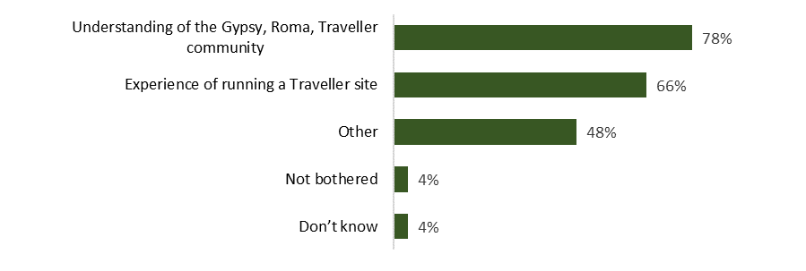

Base: all respondents (191)
Finally, respondents were then asked what, if anything, we could do differently rather than selling the three sites. Respondents were most likely to mention that there should be alternative or better management of sites and working with residents to reduce costs, improve services and be more efficient (68%).

For those respondents indicating they were a resident on one of the three sites, four-fifths (82%) mentioned that there should be alternative or better management of site and working with residents to reduce costs, improve services and be more efficient.

- What, if anything, could we do differently rather than selling the three sites?

Base: all respondents (157)

Main findings – partner organisations

Partner organisations were invited to respond to the consultation via a specific questionnaire. There were only six responses returned.

5.1 Which site are you responding about?

Respondents completing the partner organisation questionnaire were first asked which of Lancashire's traveller sites they were responding about. Five respondents said they were responding about Mellishaw Park in Morecambe, with four responding about Altham near Accrington and three about Leighton Street in Preston.

- Which site are you responding about?
 | Count
Altham near Accrington | 4
Mellishaw Park in Morecambe | 5
Leighton Street in Preston | 3
Base: all respondents (5)

5.2 Views on our proposal for the Traveller sites

Respondents were then asked how strongly they agreed or disagreed with our proposal to sell the three sites. All six respondents disagreed with the proposal.

- How strongly do you agree or disagree with our proposal to sell the three sites?
 | Count
Strongly agree | 0
Tend to agree | 0
Neither agree nor disagree | 0
Tend to disagree | 2
Strongly disagree | 4
Base: all respondents (6)

Respondents were then asked for their views on our proposal to sell the three sites. Three respondents had concern for the loss of the sites and those who live on them, and three respondents said they were not cost effective.

- What are your views on our proposal to sell the three sites?
 | Count
Concern for loss of sites and people who live on them | 3
Not cost effective | 3
Need more pitches not less and better facilities/maintenance | 2
Base: all respondents (5)

Respondents were then asked, if this proposal happened, how it would affect their organisation. Two respondents mentioned that they thought people would be displaced and two respondents mentioned concern for the Traveller community's welfare.

- If this proposal happened, how would it affect your organisation?
 | Count
People will be displaced | 2
Concern for Traveller community welfare | 2
Not cost effective | 1
Base: all respondents (4)

Respondents were then asked what we need to consider if the site they are responding to is sold. Three respondents said that selling the sites is not cost effective as it will have a knock-on effect to the local community.

- If the site you are responding about is sold, what do we need to consider?
 | Count
Not cost effective to be sold as it will have knock-on effect to local community | 3
People will be displaced | 2
Needs more information on the proposal | 2
We want Lancashire County Council to own it | 1
Base: all respondents (4)

Respondents were then asked what a potential buyer should have if the site they are responding about is sold. Four respondents said a potential buyer should have experience of running a Traveller site and four said a potential buyer should have an understanding of the Gypsy, Roma, Traveller community.

- If the site you are responding about is sold, what should a potential buyer have?
 | Count
Experience of running a Traveller site | 4
Understanding of the Gypsy, Roma, Traveller community | 4
Other | 2
Don't know | 1
Base: all respondents (5)

Finally, respondents were then asked what, if anything, we could do differently rather than selling the three sites. Four respondents commented that Lancashire County Council should retain the sites.

- If the site you are responding about is sold, what should a potential buyer have?
 | Count
Lancashire County Council should retain the sites | 4
Traveller community should be protected | 2
New owners may be detrimental to the community | 1
Residents/housing organisation should take over management | 1
Base: all respondents (4)

Other responses to the consultation

6.1 Lancaster City Council
Further to the consultation about the potential disposal of the Traveller sites in Lancashire, I am writing on behalf Lancaster City Council in relation to the Mellishaw site.

Lancaster City Council is keen to explore possible solutions with County which will result in a positive outcome for the residents and both councils as we recognise the potential distress and upset that major change and uncertainty could have on the residents of Mellishaw.

Our officers have started a dialogue with Lancashire County Council officers and wish to continue this over the coming weeks and months with a view to investigating whether there is a way the City Council could look to take ownership and either manage directly or in partnership with a social housing provider.

We hope we can work together to find a mutually agreeable solution for us all but, most importantly, for our residents on the site.

6.1 Xaverian Mission Spirituality Centre
Allow me to introduce myself. I am XXXXXXXXXXXXXX, a Catholic Priest with the Xaverian Missionaries, residing at the Xaverian Mission Spirituality Centre on 169 Sharoe Green Lane, Fulwood. I am also the Provincial Superior of the Xaverian Missionaries in the UK.I have been in Preston, on and off, for 20 years now and am very familiar with the Catholic community in Lancashire and the other faith communities. Over the years I have been involved in various campaigns of social justice from the plight of the homeless to interfaith and race relations in the area.

It has recently been brought to my attention that the Travelling Community who have been based on the Leighton Street site are facing a period of uncertainty and rightly worried about their future due to changes which are being considered by Lancashire County Council. I am familiar with many of that community and aware that the present site hosts around 15 families, numbering about 200 people. Many of these people have been in Preston, on that site for some 35 years or so, and are worried that some of the proposed changes may well endanger their livelihood, raise the real possibility of being moved from their homes, destabilise the family nucleus and present an unnecessary burden on that community. The unrest could also contribute to the already present stereotypes and discrimination that the travelling community face daily. This would certainly destabilise the social cohesion that I know the Council have been working hard to promote in Preston.

Just today, 30/07/19 the Pope at a special mass for over 7,000 Travellers in the Vatican said that the Travellers were at the heart of the Church and not on the outside. He condemned all form of prejudice and discrimination and prayed for more inclusion for this community in our society and Church. https://www.independent.ie/irish-news

As far back as 2014 Pope Francis has been aware of the plight of the Travelling Community. "Regarding the situation of Gypsies across the world, it is ever more necessary to elaborate new approaches in the civil, cultural and social sphere, as indeed in the church's pastoral strategy, to take on the challenges that emerge from modern forms of persecution, oppression and, sometimes, slavery too….” https://www.theguardian.com/world/2014/jun/05/pope-francis-defends-gypsies-vatican-address

Pope Francis has hit out at prejudice against Gypsies, urging people to stem their suspicion and calling on authorities to help those "at the margins of society" find greater means of integration.

It is to this end that I am appealing on behalf of the Travelling Community and on behalf of the Catholic Church for the Council to guarantee stability, inclusion and a dignified future to this section of our society. It is all too easy in today’s world to ignore the voice of the weakest in order to promote the often selfish interests of the powerful. I pray that is never shapes policy, because the litmus test of a civilised society is how it looks after the most vulnerable.

6.2 Morecambe Bay Clinical Commissioning Group
As the Director of Population Health for Morecambe Bay, with Bay Health and Care Partners, I am writing to add my concerns about the proposed sale of the Mellishaw Park, currently owned by Lancashire County Council and occupied by members of the Gypsy/Traveller community.

I will highlight my areas of concern and then make some recommendations in line with them.

My concerns about the sale of this site are as follows:

1) Although the sale of the site stipulates that the current residents will be able to stay on the site. There is an evidence base from other areas of the country that where the sale of other such sites has occurred, the new landlords increase the price of the rent or change the conditions of the rent agreement (e.g. no animals allowed) which then forces the travellers off the site.
2) This would leave many of the current residents homeless and therefore forced back onto the road. This will I turn have a negative impact on health and wellbeing for all and diminished educational outcomes for the children, with increased risks around safeguarding. Currently all members of this community have good links to local health services and schools and given the general poor educational and health outcomes for the traveller community as a whole, we have a duty of care to ensure these relationships are maintained.
3) Through the Poverty Truth Commission, we have established good relationships with this community, and we hope to build on this over the next few years to really establish improved physical and mental health and wellbeing for all. If these families move on from Mellishaw those relationships will be lost.

My recommendation would therefore be that the county council maintain ownership of the site and ensure the necessary upgrades to the facilities on the site are done in a timely manner or sign the site over to Lancaster City Council. If the site must be sold, I would implore the Council to sell only to a trusted housing association, who have a history of working with the Gypsy/Traveller community.

6.2 Leighton Street Caravan Park

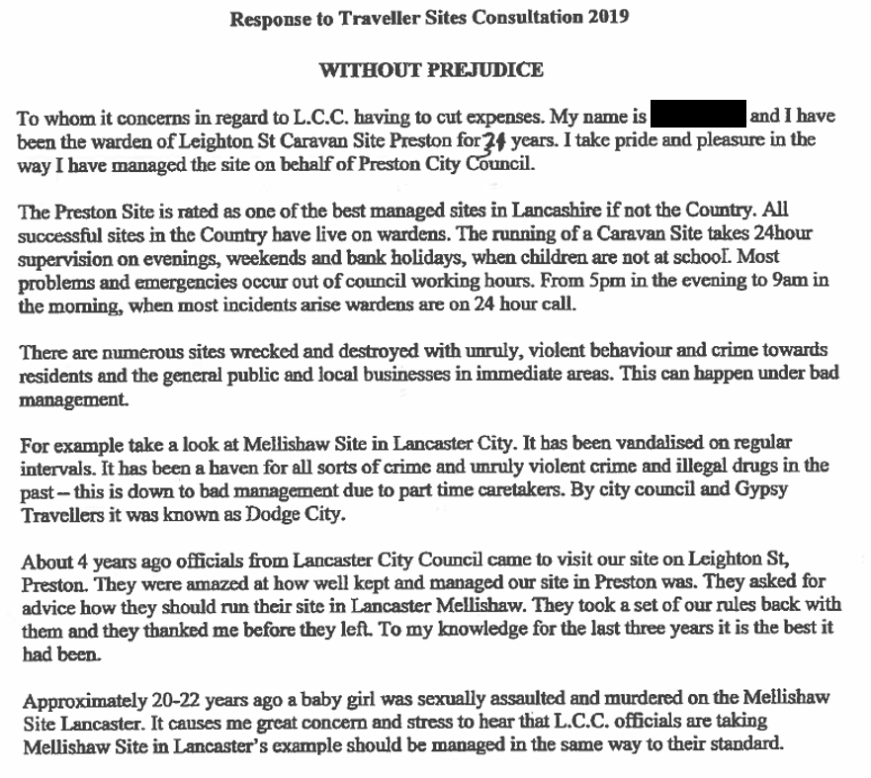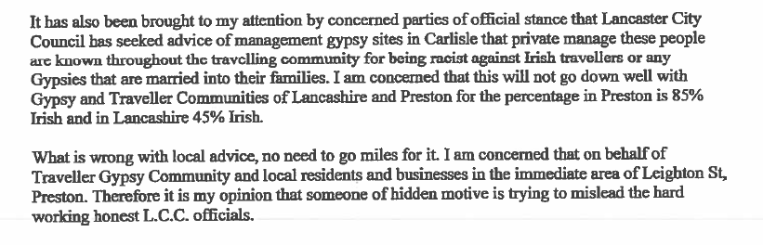

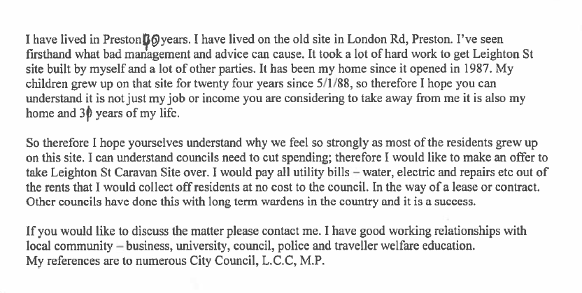

Appendix 1 - Demographic breakdown – all respondents

- Are you…?
 | %
A Lancashire resident | 81%
A resident of the Traveller sites in Altham near Accrington, Mellishaw Park in Morecambe or Leighton Street in Preston | 20%
A member of a voluntary or community organisation | 14%
Other | 10%
An employee of Lancashire County Council | 5%
An elected member of a parish or town council in Lancashire | 4%
An employee of a Lancashire district council | 2%
An elected member of a Lancashire district council | 1%
An elected member of Lancashire County Council | 1%
Base: all respondents (191)

- Are you…?
 | %
Male | 30%
Female | 57%
Other | 3%
Prefer not to say | 10%
Base: all respondents (188)

- What was your age last birthday?
 | %
Under 16 | 0%
16-19 | 1%
20-34 | 17%
35-49 | 25%
50-64 | 28%
65-74 | 16%
75+ | 3%
Prefer not to say | 11%
Base: all respondents (190)

- Are you a deaf person or do you have a disability?
 | %
Yes | 20%
No | 66%
Prefer not to say | 14%
Base: all respondents (182)

- Are there any children or young people in your household aged under 20?
 | %
No, but expecting | 2%
Yes, aged under 5 | 14%
Yes, aged 5-11 | 17%
Yes, aged 12-16 | 17%
Yes, aged 17-19 | 10%
No children aged under 20 | 42%
Prefer not to say | 12%
Base: all respondents (182)

- Are there any disabled young people aged under 25 in your household?
 | %
Yes | 9%
No | 77%
Prefer not to say | 14%
Base: all respondents (184)

- Which best describes your ethnic background?
 | % |  | %
White |  | Asian
English, Welsh, Scottish, Northern Irish, British | 57% | Indian | 1%
Irish | 3% | Pakistani | 0%
Gypsy Roma | 9% | Bangladeshi | 0%
Traveller of Irish heritage | 12% | Chinese | 0%
Any other Traveller background | 1% | Any other Asian background | 0%
Any other white background | 5% | Black or Black British | 0%
Mixed ethnic background |  | African | 0%
White and Black Caribbean | 1% | Caribbean | 0%
White and Black African | 0% | Any other mixed ethnic background | 0%
White and Asian | 1% | Other ethnic group
Any other mixed ethnic background | 2% | Arab | 0%
 |  | Any other ethnic background | 1%
 |  | Prefer not to say | 9%
Base: all respondents (189)

Appendix 2 - Demographic breakdown – residents at the Traveller sites

- Are you…?
 | %
A resident of the Traveller sites in Altham near Accrington, Mellishaw Park in Morecambe or Leighton Street in Preston | 100%
A Lancashire resident | 68%
A member of a voluntary or community organisation | 5%
An elected member of a parish or town council in Lancashire | 3%
An employee of a Lancashire district council | 3%
An employee of Lancashire County Council | 3%
Other | 0%
An elected member of a Lancashire district council | 0%
An elected member of Lancashire County Council | 0%
Base: all respondents (38)

- Are you…?
 | %
Male | 24%
Female | 74%
Other | 0%
Prefer not to say | 3%
Base: all respondents (38)

- What was your age last birthday?
 | %
Under 16 | 0%
16-19 | 0%
20-34 | 32%
35-49 | 24%
50-64 | 29%
65-74 | 13%
75+ | 0%
Prefer not to say | 11%
Base: all respondents (38)

- Are you a deaf person or do you have a disability?
 | %
Yes | 40%
No | 60%
Prefer not to say | 0%
Base: all respondents (35)

- Are there any children or young people in your household aged under 20?
 | %
No, but expecting | 0%
Yes, aged under 5 | 36%
Yes, aged 5-11 | 33%
Yes, aged 12-16 | 28%
Yes, aged 17-19 | 17%
No children aged under 20 | 28%
Prefer not to say | 0%
Base: all respondents (36)

- Are there any disabled young people aged under 25 in your household?
 | %
Yes | 15%
No | 85%
Prefer not to say | 0%
Base: all respondents (34)

- Which best describes your ethnic background?
 | % |  | %
White |  | Asian
English, Welsh, Scottish, Northern Irish, British | 8% | Indian | 0%
Irish | 3% | Pakistani | 0%
Gypsy Roma | 39% | Bangladeshi | 0%
Traveller of Irish heritage | 45% | Chinese | 0%
Any other Traveller background | 5% | Any other Asian background | 0%
Any other white background | 0% | Black or Black British | 0%
Mixed ethnic background |  | African | 0%
White and Black Caribbean | 0% | Caribbean | 0%
White and Black African | 0% | Any other mixed ethnic background | 0%
White and Asian | 0% | Other ethnic group
Any other mixed ethnic background | 0% | Arab | 0%
 |  | Any other ethnic background | 0%
 |  | Prefer not to say | 0%
Base: all respondents (38)

